Topic: Can Katie Ledecky beat Ariarne Titmus in the 800m Freestyle?

Can Katie Ledecky sustain her dominance in the 2024 Olympic Games?

**Katie Ledecky**

Age: 24

Height: 6’ 0”

College: Stanford University

Top 5 Program in US

Events: 200m Freestyle, 400m Freestyle, 800m Freestyle, 1500m Freestyle

World Records: 3

LC 400m Freestyle – 3:56.46 (2016 Olympics)

LC 800m Freestyle – 8:04.79 (2016 Olympics)

LC 1500m Freestyle – 15:20.48 (2018 TYR Pro Swim Series)

Olympic Medal Count: 9 Total

Gold: 6

Silver: 3

Bronze: 0

World Championship Medal Count: 18 Total

Gold: 15

Silver: 3

Bronze: 0

Source: Team USA Website <https://www.teamusa.org/usa-swimming/athletes/katie-ledecky>

**Ariarne Titmus**

Age: 20

Height: 5’10”

College: St. Patrick’s College (Australia)

Events: 200m Freestyle, 400m Freestyle, 800m Freestyle

World Records: 1

SC 400m Freestyle – 3:53.92

Olympic Medal Count: 3 Total

Gold: 2

Silver: 0

Bronze: 1

World Championship Medal Count: 12 Total

Gold: 6

Silver: 4

Bronze: 2

Source: Swimming Australia Website <https://www.swimming.org.au/athletes/ariarne-titmus>

Ledecky’s 2020 Olympic Schedule:

Sunday, July 25

400m Freestyle Prelim

400m Freestyle Final

3:57.36, Silver, opened with lead but faded.

Monday, July 26

200m Freestyle Prelim

1500m Freestyle Prelim

200m Freestyle Semi

Tuesday, July 27

200m Freestyle Final

1:55.21, 5th, hung just behind Titmus but never made a move

1500m Freestyle Final

15:37.34, Gold, held lead from start to finish.

Wednesday, July 28

4x200m Freestyle Relay Prelim

4x200m Freestyle Relay Final

1:53.76, Silver, anchored relay, entered in 3rd and chased down Australia and nearly closed gap with China to win gold.

Thursday, July 29

800m Freestyle Prelim

Friday, July 30

800m Freestyle Final

Source: Sport News Website <https://www.sportingnews.com/us/athletics/news/katie-ledecky-medals-2021-olympics/pn7flfj8qk91zkunf0nxnfdt>

Titmus’s 2020 Olympic Schedule:

Sunday, July 25

400m Freestyle Prelim

400m Freestyle Final

3:56.69 (Olympic Record) Gold, chased down Ledecky.

Monday, July 26

200m Freestyle Prelim

200m Freestyle Semi

Tuesday, July 27

200m Freestyle Final

1:53.50 (Olympic Record), Gold, hung in 4th and makes move on final 50 of race

Wednesday, July 28

4x200m Freestyle Relay Prelim

4x200m Freestyle Relay Final

1:54.51, Bronze, opened relay, finished 2nd just behind China.

Thursday, July 29

800m Freestyle Prelim

Friday, July 30

800m Freestyle Final

Source: Olympics Website <https://olympics.com/tokyo-2020/olympic-games/en/results/swimming/athlete-profile-n1482877-titmus-ariarne.htm>

Race History: 2019 Worlds Aquatic Championship Women’s 800m Freestyle Results:

1st: Katie Ledecky 8:13.58

2nd: Simona Quadarella 8:14.99

3rd: Ariarne Titmus 8:15.70

Source: FINA Website <https://www.fina.org/competitions/95/18th-fina-world-championships-2019/results?disciplines=&event=218a2b07-6310-4a91-99a3-a560927263d7>

“Women achieved peak freestyle swim speed at ages 20–21 years for all distances with the exception of 800 m. In the 800 m, women were fastest at ages 26–27 years.”

Source: Public Medical Journal <https://www.ncbi.nlm.nih.gov/pmc/articles/PMC3781914/#:~:text=Women%20achieved%20their%20peak%20freestyle,27%20years%20(Figure%204)>.

“There are approximately 54.6 yards in 50 meters, so a 50 free (for example) in Short Course is a shorter distance to swim than a 50 free in Long Course.”

Source: Team Unify Website <https://www.teamunify.com/SubTabGeneric.jsp?team=mvsmsa&_stabid_=155746>

The following graphs show all of Katie Ledecky’s championship times. In the shorter distances, her best times occurred in 2016, and for the 1500, in 2018. In recent years, her times have slightly increased.

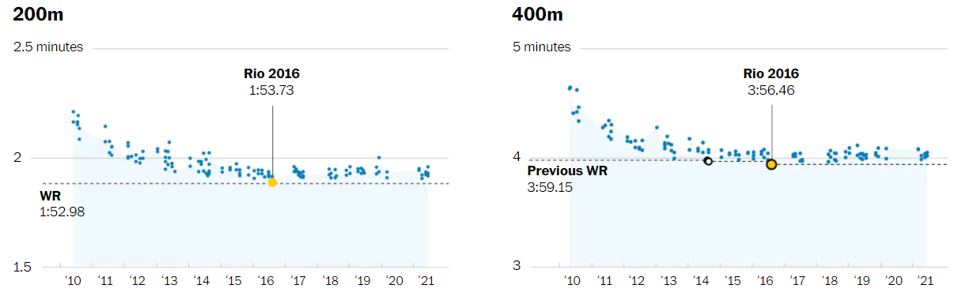

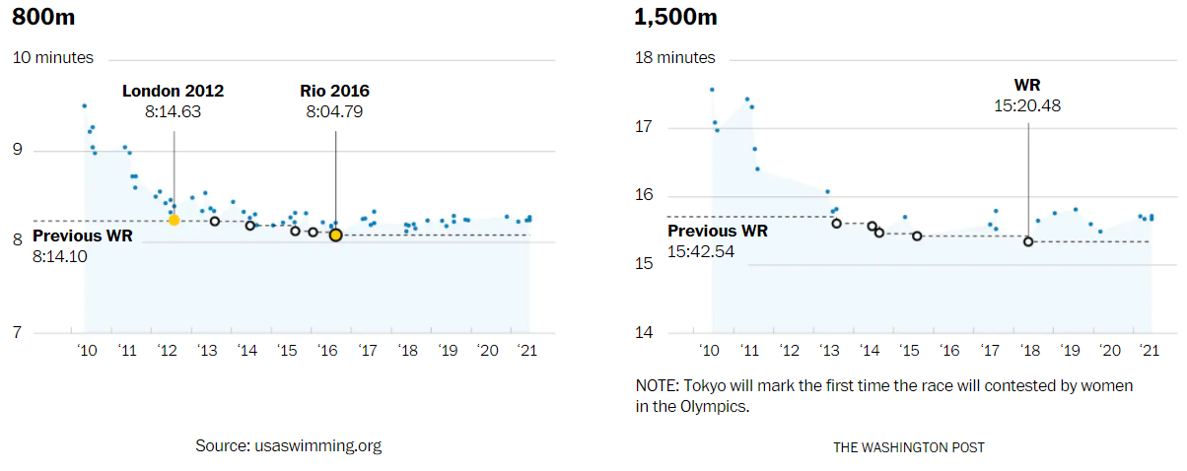

Source: Washington Post <https://www.washingtonpost.com/sports/olympics/interactive/2021/katie-ledecky-swimming-olympics/>

However, you can see in the following plots that in recent years, other female champion swimmers have been able to drop time after their expected peak age of performance for their event.

These graphs also show that Titmus is peaking at a slightly older age than when Ledecky peaked, especially in the 400m Freestyle.

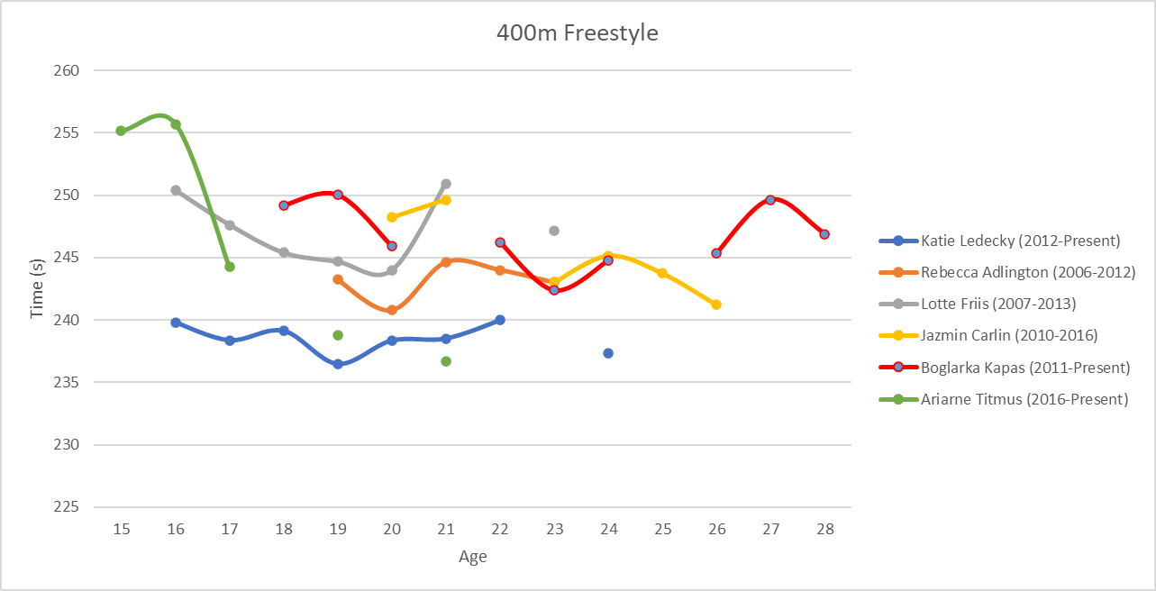

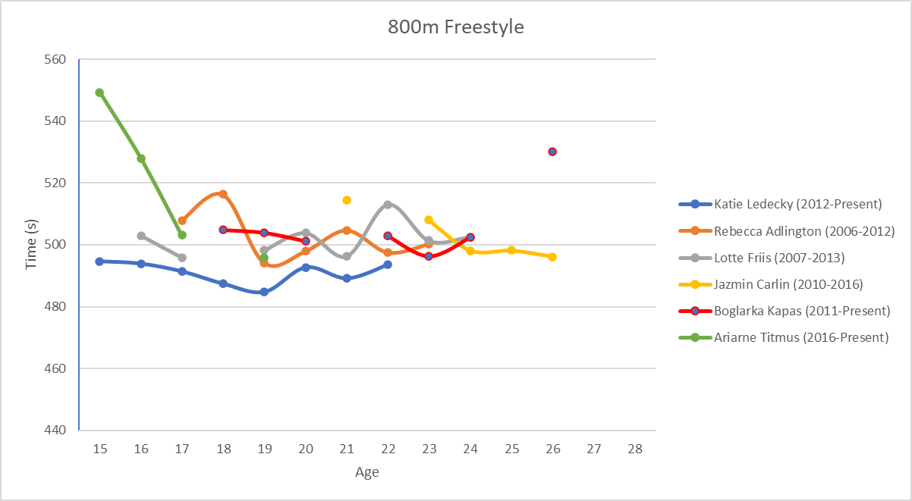

Source: Swimcloud.com for time data and Microsoft Excel to combine and plot the data.

I couldn’t find the following information online and didn’t have enough time to collect it myself, but I would love to obtain data for Ledecky’s “time of victory,” how much time Ledecky won by in her events and see how it has trended throughout the years in comparison to other dominant freestylers. Is Katie just slowing down? Are people catching up to Ledecky?

Arguments based on the research:

Yes, Katie will beat Ariarne. Scientific research shows that women peak at the 800 around age 26-27, which Katie Ledecky is closer to that age. This event is not Ariarne’s event, she is better at shorter distances.

No, Ariarne will upset Katie. Ariarne has been dropping time. She is rested because she did not swim the 1500. Katie has been gaining time in recent years.

Katie will remain dominant in 2024, particularly in long distance events, as she will be 27, which is in the peak age for 800m swimming as shown in research. There is precedent for long distance swimmers who have been able to cut a little more time in the 400 and 800m around age 27. But we should also ask, does she need to rebreak her records to remain great.

Katie’s dominance will come to an end by 2024. Ariarne Titmus has surpassed Katie in the 400m, and Katie will not be as competitive by age 27 in a short distance event like the 400m. While Katie may peak at age 27 in the 800m, Ariarne will also have 3 more years of experience and improvement to continue to chase Katie.